Teachers / Leaders Guide

Camp Qld
170 Ski Zone Road
Moogerah Qld 4309

Table of Contents
WHAT TO PACK FOR A STANDARD 3-DAY CAMP
TEACHERS’ ‘DON’T FORGET’ LIST
BEDDING ALLOCATIONS
OTHER ACCOMMODATION LAYOUT:
ARRIVAL TO CAMP
FIRST AID
EMERGENCY NUMBERS
MEALS
SAMPLE 3 DAY CAMP MENU:
RESPONSIBILITIES FOR TEACHERS AND LEADERS AT CAMP QLD
Emergency Vehicle:
Food
Food Portions
Movie Night
ACTIVITY CONSENT FORM & APPROVAL
Hold Harmless Agreement:
MEDICAL FORM FOR SCHOOL EXCURSIONS AND SPORTING EVENTS

Camp Qld Map
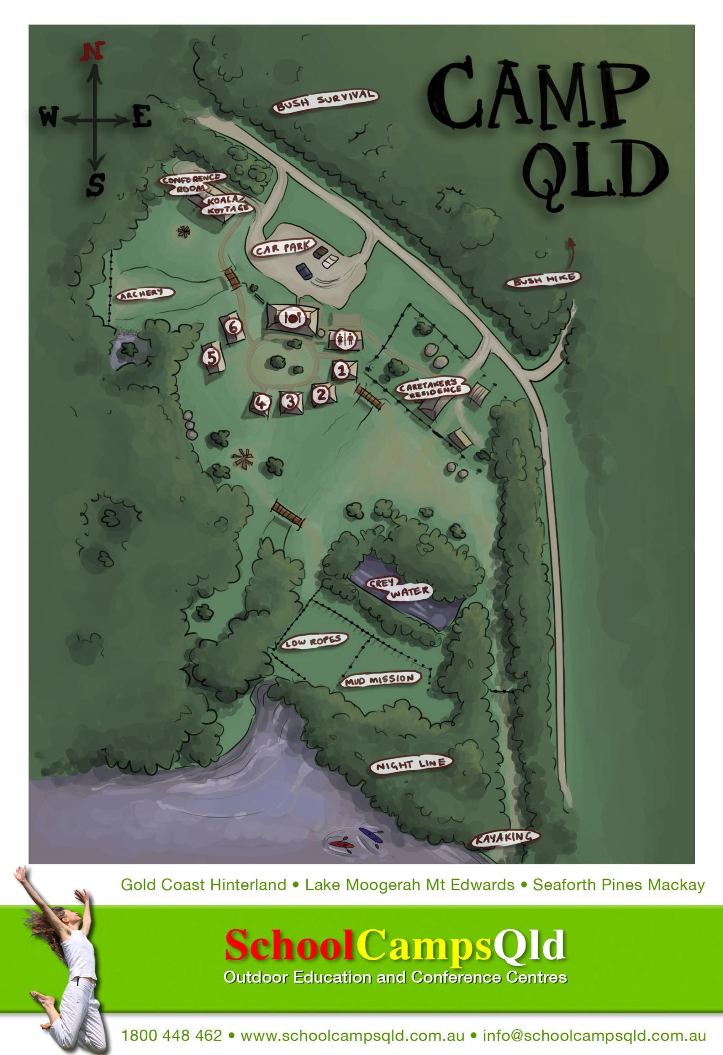

Your Teachers and Leaders School Camp Checklist

Due Date | Task | Completed | Date Completed
On booking | Pay deposit to confirm booking
 | Sign Booking Confirmation – delivered via email
Once deposit is paid | Receive Teachers Guide
 | Organise Students Permission Forms and Payments
 | Receive Sample Program
 | Receive Risk Assessments
21 Days before Camp | We will contact you to answer any questions or make any last minute changes
14 Days before camp | We will email you to confirm:  - Final Numbers  - Dietary Requirements  - Arrival and Depart Time  - Confirmation of Program
 | Ensure your final invoice has been paid by your Accounts Payable Department
After Camp | We will email you a feedback form – Please fill in and press send
 | Please ensure you book your dates for next year for camp

What to Pack For a Standard Camp

For longer camps, add an item per day e.g. 5 days – 5 complete changes of clothes…

- Torch
- Water Bottle
- Hat
- Sun Screen
- Insect Repellent
- Set of clothing for each day at camp plus 1 spare
- A throwaway set of clothes and shoes (Mission Mud Course)
- Underwear and socks for every day plus 1 extra pair of each
- Extra warmer clothes for evenings
- Bathers/swimmers and a beach towel
- 2 pairs of enclosed shoes and an additional ‘wet’ pair to wear in the lake (Thongs or Crocs are not suitable)
- Sleeping bag, fitted sheet and pillow
- Toiletry bag plus
- Personal medication (to be handed into teachers)
- Appropriate sleeping attire
- Rain Coat
PLEASE NOTE – Any CAMPOUT students need to bring the following per student:
- Tea Towel
- Cutlery – Knife, Folk & Spoon
- Plate, Bowl, Camp Mug, water bottle
- Sleeping Mat (Foam – NO Blow ups)

Winter
- Jacket, gloves, slippers
- Plenty of warm clothes
- Inner sheet for sleeping bag or extra bedding
- Beanie
- Scarf
- Warm flannel pyjamas

Teachers’ ‘Don’t Forget’ List

Odd Items that sometimes get forgotten:

- A pillow for every child (get children to sit on pillows in bus)

- Slab of bottled water for any students who forget their water bottle! Very important to keep hydrated during camp.

- A throwaway set of clothes & shoes for the commando/mud course. They may never come clean again!

- Final numbers must be given to us via admin@schoolcampsqld.com.au two weeks prior to camp arrival date. These are numbers that will be invoiced and payment is required to be paid before camp. If payment is not received, we cannot guarantee the camp will go ahead.

- If extra students come to camp, a supplementary invoice will be issued. If numbers decrease, the camp will charge based on final numbers given 14 days in advance of camp.

- Two weeks before camp, please email admin@schoolcampsqld.com.au to confirm your numbers and inform us of any dietary requirements such as vegetarian along with medical conditions, allergies & religious diets. We do not cater for likes & dislikes.

- A numbered list of all campers and leaders to be given to School Camps Qld on first day.

- A comprehensive first-aid kit must be bought to camp with you.

- Sports equipment for free time. e.g. volleyballs, basketballs, cricket set etc.

- Camp QLD address 170 Ski Zone Road, Moogerah

Bedding Allocations

Please allocate names of students/attendees for Fire and Safety Management:

- Cabin 1 to 4 – Sleep 12
- Cabin 5 – Sleeps 4 teachers/24 Students – Extra beds can be added
- Cabin 6 – Sleeps 3 teachers/24 Students - Extra beds can be added

*Children Under 9 years are recommended not to sleep in top bunks

"Cabins must be full (all 12 OR 30 beds occupied) before allocating people to the next cabin given as your allocation. If a room or cabin is not showing on your allocation, please contact us on 1800 448 462. “

Cabins 1 - 4 are split with 6 beds on each side of a wall

It is suggested that you fill the bottom bunks first and place older children or adults in top bunks.

Cabin 1 to 4 – Sleep 12 Students – Extra beds can be added

Cabin ONE | Lower Bunks | Upper Bunks
Maximum 12 Singles  Please contact the office if you require more beds | 1. | 7.
 | 2. | 8.
 | 3. | 9.
 | 4. | 10.
 | 5. | 11.
 | 6. | 12.

Notes:

Cabin TWO | Lower Bunks | Upper Bunks
Maximum 12 Singles  Please contact the office if you require more beds | 1. | 7.
 | 2. | 8.
 | 3. | 9.
 | 4. | 10.
 | 5. | 11.
 | 6. | 12.

Notes:

Cabin THREE | Lower Bunks | Upper Bunks
Maximum 12 Singles  Please contact the office if you require more beds | 1. | 7.
 | 2. | 8.
 | 3. | 9.
 | 4. | 10.
 | 5. | 11.
 | 6. | 12.

Notes:

Cabin Four | Lower Bunks | Upper Bunks
Maximum 12 Singles  Please contact the office if you require more beds | 1. | 7.
 | 2. | 8.
 | 3. | 9.
 | 4. | 10.
 | 5. | 11.
 | 6. | 12.

Notes:

Cabin FIVE | Lower Bunks | Upper Bunks
5 Room A  Maximum 6 Singles | 1. | 4.
 | 2. | 5.
 | 3. | 6.

5 Room B  Max 3 Singles - Teachers | 1. | 4.
 | 2.
 | 3.

5 Room C  Maximum 6 Singles | 1. | 4.
 | 2. | 5.
 | 3. | 6.

Continued on next page

5 Room D  Maximum 12 Singles | 1. | 7.
 | 2. | 8.
 | 3. | 9.
 | 4. | 10.
 | 5. | 11.
 | 6. | 12.

Cabin SIX |  | Lower Bunks |  | Upper Bunks
6 Room A  Maximum 6 Singles | 1. |  | 4.
 | 2. |  | 5.
 | 3. |  | 6.

6 Room B  Max 3 Singles - Teachers | 1.
 | 2.
 | 3.

6 Room C  Maximum 6 Singles | 1. | 4.
 | 2. | 5.
 | 3. | 6.

6 Room D  Maximum 12 Singles | 1. | 7.
 | 2. | 8.
 | 3. | 9.
 | 4. | 10.
 | 5. | 11.
 | 6. | 12.

Cabins 1 to 4
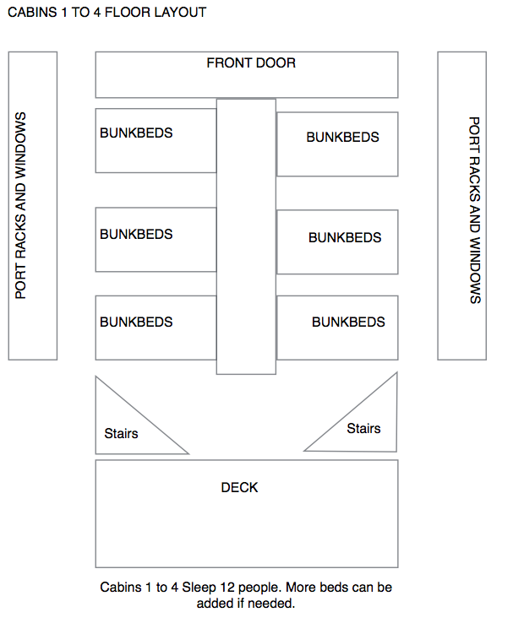

Cabin 5 and 6

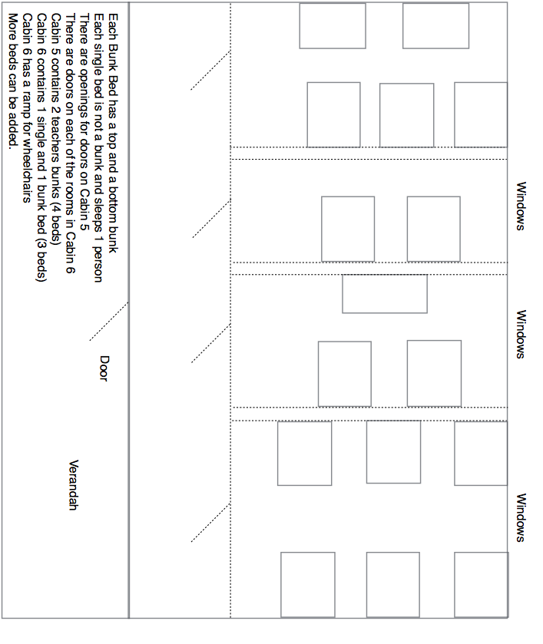

Camping Allocations – Leadership Under the Stars

Tent No: | Student Names
Maximum 9 Singles  Please contact the office if you require more beds | 1.
 | 2.
 | 3.
 | 4.
 | 5.
 | 6.
 | 7.
 | 8.
 | 9.

Tent No: | Student Names
Maximum 9 Singles  Please contact the office if you require more beds | 1.
 | 2.
 | 3.
 | 4.
 | 5.
 | 6.
 | 7.
 | 8.
 | 9.

Please photocopy this page if you require more tents. Each is to be filled before moving onto the next.

Arrival to Camp
- On arrival, please remain on bus for our Camp Co-ordinator to welcome -There is plenty of room for buses to turn around.

- You will be met in the car park by your Camp Co-ordinator. Please have the students remain on the bus at this stage.

- Your Camp Co-ordinator will introduce themselves to you and the students and instruct them ON the bus. You may then proceed from the bus. All students must collect their bags and proceed to the grassed area awaiting further instructions.

- Students will then be allocated to their cabins using the bedding allocation list you have previously prepared – Please hand Bedding Allocation list to your Camp Co-ordinator

Cabins will be allocated depending on numbers in your group.
You will not have access to all of the cabins if your numbers fall below 96. The cabins are as follows:

Cabin 1 to 4: 6 bottom bunks / 6 top bunks in each cabin
TOTAL: 48 IN 4 CABINS
Cabin 5 to 6: 12 bottom bunks / 12 top bunks in each cabin
TOTAL: 48 IN 2 CABINS

TOTAL CAPACITY: 96 students – If you need extra beds please advise as they can be added.

Please check with us on 07 5543 8076 which cabins are assigned to your group before you write up your bedding allocation.

Once students have deposited their bags to their rooms, they are required to sit in the recreation hall or the grassed area in their teams. Depending on numbers, you may need to split your group into 4 teams or 6 teams. Please check with us on 07 5543 8076 regarding how many teams you will need to allocate prior to arrival.

Your activities program will indicate the number of teams you require.

First Aid
It is the responsibility of teachers / group leaders to provide First Aid to any children or students who need it. Facilitators do carry small First Aid Kits to all activities and act in accordance with the legal requirements set out by Queensland Ambulance guidelines.

However, teachers / group leaders are ultimately responsible for administering First Aid. There is ICE available at the kitchen. Facilitators and instructors are not permitted to leave their activity area and so a teacher or group leader would need to get the ice and make the emergency phone calls required in line with school protocol and procedure.

Facilitators carry mobile phones at al times and phones are located in the kitchen and the staff quarters for emergency phone calls.

Telstra Mobile and Optus has some coverage at Lake Moogerah.
Do not rely on mobile phones to receive calls. There is also an after hours caretaker who can be reached for an emergency or staff are located in the staff house also for emergencies.

Groups are required to bring a vehicle for emergency use
And are also required to bring and use their own first aid kits.
Permanent School Camps Qld staff hold current First Aid Level 2 qualifications.

SCQ staff will be responsible for the technical safety of campers during activity sessions run by SCQ. An area has been set aside for first-aid in the dining room. A School Camps Qld first-aid kit is available for emergency use upon request. Groups will be billed for bandages etc.
A copy of the Emergency Procedures is available on the main noticeboard and in every hut. There is a telephone for emergency calls in the office. Emergency numbers are pinned to the wall near the telephone.

Emergency Numbers

Emergency Numbers
Police/Fire/Ambulance | 000
Mobile call Police Fire ambulance | 112
Beaudesert Hospital | 5541 1411
Boonah Hospital | 5463 3300
SES | 5540 5131
Poisons Information | 13 11 26
Boonah Police Station | 5463 3999
Leanne Conoley – Owner | 0404 447 163
Camp Qld Kitchen | 07 5463 8553

Meals

At Camp Qld we like to involve the kids at meal-time preparation so they feel a sense of responsibility, ownership and team work.

Duty Groups are in line with activity groups. During each meal, duty groups will be required to be at the Recreation Room Kitchen 30 minutes before scheduled meal times. Duty Groups will then have responsibilities to get the dining area ready and help serve meals.

Duty Groups will also eat before other students. If you are having activities, duty groups will fall in line with these. If no activities, please divide your group into smaller groups of 12 to 15 students -

If you prefer not to have DUTY GROUPS, there is an extra cost for wait-staff service. This depends on numbers. Please advise if this is the case.

Supper
Supper is provided free of charge. Hot Chocolate and biscuits will be available for you to have at your leisure.

Coffee and Tea Station
A coffee and tea station is available for teachers and leaders only to use at their leisure. Please do not allow children or students to use this facility.

Food
We do cater main meals for vegetarian, dairy/lactose free and gluten free diets however please ask students and teachers with special diets to bring along snacks and preferred foods with them to camp that are suitable to their dietary requirements.

I would also recommend that other special diets e.g. food colouring intolerances, low sodium diets and fussy eaters also bring food along with them to the camp to guarantee their dietary requirements are fulfilled to provide sustenance during very physical activities.

We Endeavour to provide a high standard of nutritious meals for students and teachers alike however we would not like anyone to go with out.

Our chef is more than happy to prepare the food for them which we will keep it in our cool room for the duration of the camp.

Food Portions
Food is an essential aspect of our camps and we like it taste wonderful, be filling and healthy for all of the activities your students will be participating in. Therefore, we portion the food accordingly. There are always seconds and if any student is hungry or if any of your students are not eating for one reason or another, please report to the kitchen ASAP so that they can have more to eat.

Sample 3 day camp menu:

Morning Tea
Choc Chip Cookies and a ‘Help Yourself’ Fruit Bowl
Lunch
Traditional Hamburgers served with Pineapple, Beetroot, Cheese, Caramelized Onions, Crispy Salad and Condiments
Afternoon Tea
Vegemite and Cheese Puff Pastry Scrolls and a Fruit Platter
Dinner
Spaghetti Bolognaise served and Garlic Bread
Vanilla Ice Cream and Toppings
Supper
Hot Chocolate and Biscuits

Breakfast
Choice of Cereals, Crispy Bacon and Scrambled Eggs on Toast, and Juice
Morning Tea
Homemade Muffins and a ‘Help Yourself’ Fruit Bowl
Lunch
BLT’s Sandwiches
Afternoon Tea
Jam Puff Pastry Scrolls and Fruit Platter
Dinner
Chicken Schnitzel, Creamy Potato Bake served with Garden Vegetables
Two Fruits and Custard
Supper
Hot Chocolate and Biscuits

Breakfast
Selection of Cereals, Toast, Fluffy Pancakes served with Maple Syrup
Morning Tea
Gruffalo Slice and a Fruit Platter
Lunch
Sausage Sizzle on a Hot Dog Bun served with Caramelized Onions, Salad and Condiments
* Chilled water available all day. Cordial served with dinner only. Continuous Tea and Coffee for Teachers only.
Menu subject to change without notice

Dietary Requirements
Fresh fruit is always available for special dietary guests – please request from the Cook / Kitchen team if required.
Soya Milk and other dietary requirements are available. However, it is highly recommended that students and teachers bring along snacks and their preferred brands of pasta, bread etc. As the brands we use may not be their preference.

Guests Name | Vegetarian  A meal free of any meat product. | Vegan  A meal free of ANY animal derived products  OVO – eats eggs and no dairy  LACTO eats dairy and no eggs  LACTO OVO eats eggs and milk | Gluten, Wheat Free & Celiac  A meal free of any wheat & gluten | Dairy Free / Lactose intolerant  No dairy used in meals | Peanut Allergy  Please indicate if the guest carries and Epi Pen
Please indicate if the guest has any other food intolerance plus any other requirements we may need to know.

Responsibilities for Teachers and Leaders at Camp QLD

Lead Teacher/Group Leader is responsible for:

- Collecting and bringing consent forms
- Medical forms
- Bedding allocation for fire register
- Entering into the School Camps Qld Illness/Injury registers any illnesses or injuries that occur whilst at camp.
- A list of names of all campers must be handed to School Camps Qld staff on arrival.

There must be one teacher/group leader with every activity group of children. The recommended national ratio is 1 teacher to 15 children.

Teachers on Swimming activities are required to hold a Bronze Medallion in Lifesaving. This is recommended by the Education Department and is on all Risk Assessment Documentation.

As the camp is situated on a lake, School Camps Qld and Camp Qld are not responsible for any supervision of swimming. Your leaders and teachers are responsible at all times for swimming supervision of your students and campers. A life-guard is not provided unless specifically requested and is an added cost.

One teacher/group leader must supervise the duty group of children that set up and clean up after meals. If you prefer not to clean up a cleaning fee will be invoiced to the school for cleaning. This also applies to toilets and showers and camp clean up. If the camp is not left in the cleanliness and standard that you arrived in, a cleaning fee will be charged.

Teachers/group leaders are responsible for children during all non-activity time. Eg free time, meal times, night-time.

Teachers are also responsible for students throughout the entire camp. Especially students behaviour and safety.

School Camps Qld facilitators do hold First Aid Qualifications. However, teachers are required to administer first aid in all cases.

While School Camps Qld Program Staff will be responsible for the technical safety of campers when they are instructing an activity it is the responsibility of teachers/group leaders to ensure that discipline is maintained.

Teachers and supervisors are welcome to participate in activities. However, please beware that if any person is required to leave an activity, the teacher/supervisor may need to leave with them. For example in case of an emergency or first aid requirement (getting ice etc)

In situations where School Camps Qld Program Staff are working one to one with an individual student e.g. abseil, pamper pole, the teacher/group leader is responsible for the rest of the group.

Teachers / group leaders are also responsible for all swimming supervising of children. Though a facilitator may be present during a swimming activity (such as the Adventure Hike), teachers and group leaders are responsible for safety of all children and young adults during swimming.

It is recommended that shoes be worn during all swimming events at natural rock pools. It is also not recommended to allow children, students and young adults dive or jump in any swimming holes.

Emergency Vehicle:
It is recommended that at least one teacher brings a vehicle to camp in case of emergencies.

Movie Night
Please BYO movies for movie night as different schools have different requirements

Activity Consent Form & Approval
This form is to give consent for school excursion activities whether staying overnight or day visiting. Activities may include: Archery / Swimming / Mission Mud Course/ Bush Survival / Outback Art / Star Warts Night Game / Big Screen Movie Night – G rating movies only – BYO Movies / Bonfire night / Orienteering / Games and Initiatives / Adventure Hike an / Bush Walking / Kayaking / Short transport on a commercially licensed coaster for transfers if needed.
The participant listed below, has approval to participate in all of the above activities along with any other activity which may occur during the weekend. E.G Excursion / Outing - These activities will be notified in advance unless an emergency occurs.

From _______ to ___________Without restrictions or special considerations:

First Name
Last Name
Address
City |  | P/C:
D.O.B |  | Age:
Email
Mobile |  | Phone:

Hold Harmless Agreement:
I understand that participation in School Camps Qld / Camp Qld activities involves a certain degree of risk and can be physically, mentally, and emotionally demanding. I have carefully considered the risk involved and have given consent for myself or my child to participate in this activity. I also understand that participation in this activity is entirely voluntary and requires participants to abide by applicable rules and standards of conduct. I release School Camps Qld, the local council, the activity coordinators, and all employees, volunteers, related parties, or other organisations associated with the activity from any and all claims or liability arising out of this participation. I also allow outdoor group photos to be taken of my child and used for other school promotional purposes.In case of emergency involving my child, I understand every effort will be made to contact me. In the event I cannot be reached, I hereby give my permission to the medical provider selected by the adult leader in charge to secure proper treatment, including hospitalisation, anaesthesia, surgery, or injections of medication for my child. Medical providers are authorised to disclose to the adult in charge examination findings, test results, and treatment provided for purposes of medical evaluation of the participant, follow-up and communication with the participant’s parents or guardian, and/or determination of the participant’s ability to continue in the program activities.

Parent / Guardian Signature:
Date of Signature:

Camp Qld STUDENT MEDICAL AND PROGRAM CONSENT FORM
This information is confidential and will not be used to deny participation in the program.

School /
Organisation
First name |  |  |  |  | Last name
Address
Suburb / Town |  |  |  |  | State: |  |  | P/C
Emergency Contact 1
Name & Relationship
Phone Number: (H) |  |  |  | Phone Number: (Work/Mobile)
Emergency Contact 2  Name |  |  |  | Relationship
Phone Number: (H) |  |  |  | Phone Number: (Work/Mobile)
We must be able to contact the above people 24 Hours a day
Doctors Name: |  |  |  |  | Phone Number:
Ambulance Subscriber: Y / N |  |  | If Yes, Number please:
Private Health Fund: Y / N |  |  | Number:

Medicare Number:

MEDICAL HISTORY
When was your last Tetanus Booster ___/____/___
If 10 years + you are advised to arrange a booster before program
Is your child fully immunised? _________________________________________________________

Have you ever suffered from: | YES | NO | If YES please give further details and complete section for Prescribed Medication
Asthma
Allergies - Plants / Food / Insects
Diabetes
Epilepsy
Heart Problems
Recent Illness / Operations
Sleep Walking
Migraines
Behavioural Issues eg ADD
Disabilities
Current Infection Diseases
Other

Is your child currently taking medication?
Drug Name | Dosage | Frequency | Doctor Instructions
Please sure medication is clearly labelled with child’s name and dosage and requirements and handed to the accompanying
adult before departure to Camp Qld. No medication is to be carried by a child unless accompanying adult it advised.

Do you authorise the provision of Panadol to the participant should the need arise? Yes / No

Signed (Parent/Guardian if participant is under 18): __________________________________________

If “yes”, please state the dosage_____________________________________________

Does your child wear contact lenses? Yes / No

Does your child have any other condition we should be aware of? Yes / No

Details:
____________________________________________________________________________________________________________
If you have any further details which may assist us in taking care of your child during this program, please attach a separate note to this form. You may also wish to discuss any concerns with us personally.

Further information attached to this form: Yes / No

DECLARATION
This medical information is confidential and will be used to help Camp Qld staff respond to any injury or condition that may arise throughout the duration of the Camp Qld program. The completion of all sections is very important.
I acknowledge that through participation in the program activities, as organised by Camp Qld, that in addition to usual risks inherent, certain other risks and dangers may be encountered, which may include (but not limited to): remoteness to normal medical services, moderate physical exertion for which my child may not be prepared; weather extremes subject to sudden unexpected change; evacuation difficulties if my child is disabled. I accept the fact that while Camp Qld staff are skilled and experienced, they can not guarantee my child’s safety since some risks are beyond their control. My child willingly agrees to follow and comply fully with the safety standards and procedures as described by Camp Qld staff for each activity my child participates in.
In an emergency, I understand every effort will be made to contact parent/guardian immediately, however, I hereby authorise employees of Camp Qld in obtaining on my behalf of such medical assistance as my child may require in the event of an accident/illness. I further authorise qualified medical practitioners to administer anaesthetic if the need arises. I understand that I am responsible for the costs incurred in obtaining such medical attention/treatment. I agree that this agreement shall be governed in all respects by and interpreted in accordance with the Laws of Australia.

Print Name: _____________________________________________________ Date: _____/_____/_____

Signature of Parent/Guardian: ______________________________________________________________

Please list all medications that your child requires during school hours.
Please also list medication administered at home and any emergency medications.

Name of medication | Strength (eg 10mg) | Dosage (eg 1 tablet) | Route (eg oral, via PEG) |  | Time/s to |  | Time/s given at home | Other useful instructions or information
 |  |  |  |  | be given at camp

For Medication Form Page 27:
Parent/Carer Print name: ____________________________________________________________________________________________________
Signature: ________________________________________________________________________________________________________________
I hereby request that school staff administer the necessary medication to my child while at school. I agree to notify the school, in writing, if there are any changes in the above medication.
Authorising Practitioner Print name: ____________________________________________________________________________________________

Phone: ___________________________________________________Date: / / For school staff to administer over-the-counter medication, authorisation is required from a medical practitioner
The following points are for security and safety purposes, and are requirements of the Health (Drug and Poisons) Regulation 1996 (Qld).
- The parent notifies the school in writing to administer medication. This may include written guidelines from the prescribing health practitioner, including potential side affects or adverse reactions.
- Provide medication in original pharmacy labelled container to the camp.
- Ensure medication is not out of date and has an original pharmacy label with the student’s name, dosage and time/s to be taken.
- Notify the school in writing when a change of dosage is required. This instruction is to be accompanied by a letter from a prescribing health practitioner or change of label from a pharmacist.
- The student has received a dose at home without ill effect.
- Advise the camp in writing and collect the medication when it is no longer required on camp.
- Where parents are working with a prescribing health practitioner to determine a dose for that day(e.g. insulin, Rivotril)parents will provide a letter from the prescribing health practitioner instructing that parents will be responsible for notifying the school of the adjusted dose.
Uncontrolled copy. Refer to the Department of Education, Training and Employment Policy and Procedure Register at http://ppr.det.qld.gov.au to ensure you have the most current version of this document. Page 1 of 1

